Secure Coding Lab – 6

Dasari Mohan Amritesh

18BCN7038

**Write a python script to get all the file names in the current directory:**

import os

basepath = 'F:/College Stuff/Secure Coding/Lab'

for entry in os.listdir(basepath):

if os.path.isfile(os.path.join(basepath, entry)):

print(entry)

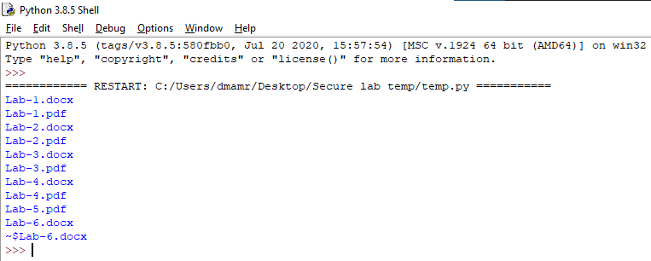

**Write a python script to get all the directory names in the current directory:**

import os

basepath = 'F:/College Stuff'

for entry in os.listdir(basepath):

if os.path.isdir(os.path.join(basepath, entry)):

print(entry)

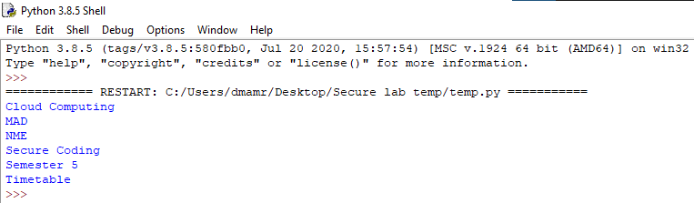

**Write a python script to get all the directory and subdirectory names in the current directory:**

import os

for dirpath, dirnames, files in os.walk('.'):

print(f'Found directory: {dirpath}')

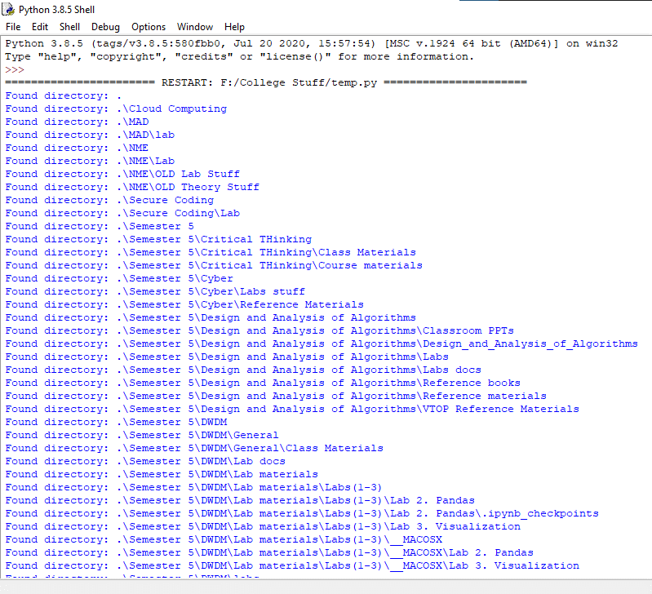

**Write a python script to get all the file name, directory and all the subdirectory names(recursively) in the current directory:**

import os

for dirpath, dirnames, files in os.walk('.'):

print(f'Found directory: {dirpath}')

for file_name in files:

print(file_name)

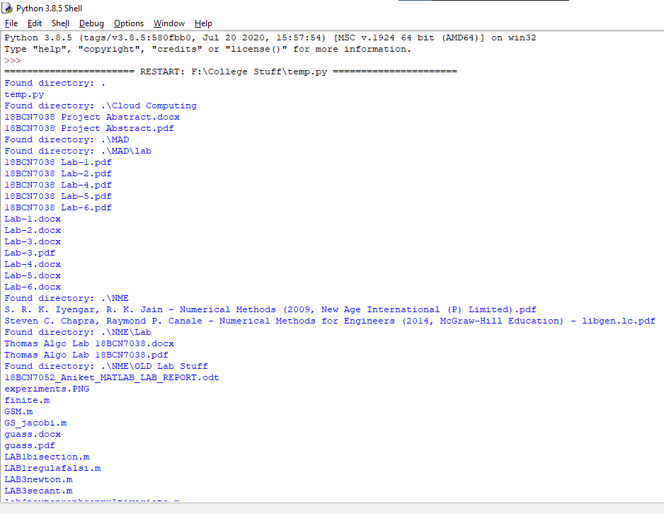

**Write a python script to get all the file name, directory and all the subdirectory names(recursively) in the current drive and write it to a text file:**

import os

f= open("test.txt","w+")

for dirpath, dirnames, files in os.walk('.'):

print(f'Found directory: {dirpath}')

f.write(dirpath+" ")

for file_name in files:

print(file_name)

f.write(file_name+"\n")

f.close()

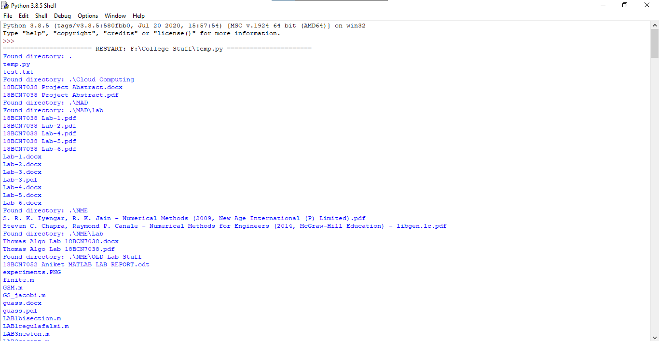

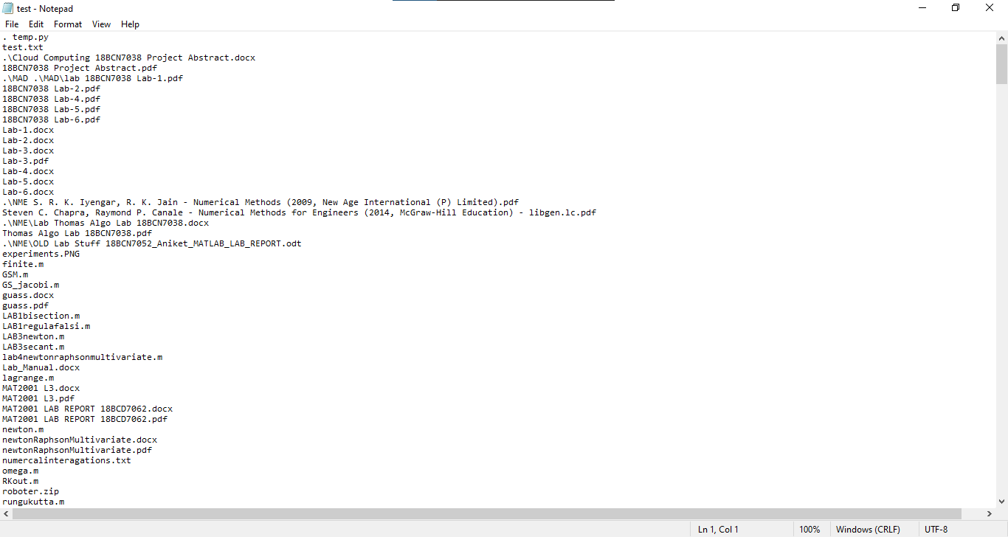

**Write a python script which creates four new files in the current directory using Powershell:**

import os

path = os.getcwd()

for i in range(1,5):

with open(path+"\{}.txt".format(i), "w") as f:

f.write("\n this my files ")

